**Introduction to Data Modelling – CA**

# Area of interest chosen

# Online chess game platform.

# Technologies used

* MySQL Workbench: Development environment.
* Notepad++: Formatting queries.
* Draw.io: ERD.
* C# .NET: Converting PGN to Inserts for table Move.

# Assumptions

Ids are not auto incremental because I choose ORM approach which defines the auto incremental. Also, for making easy the population of tables.

# Entity Relationship Diagram

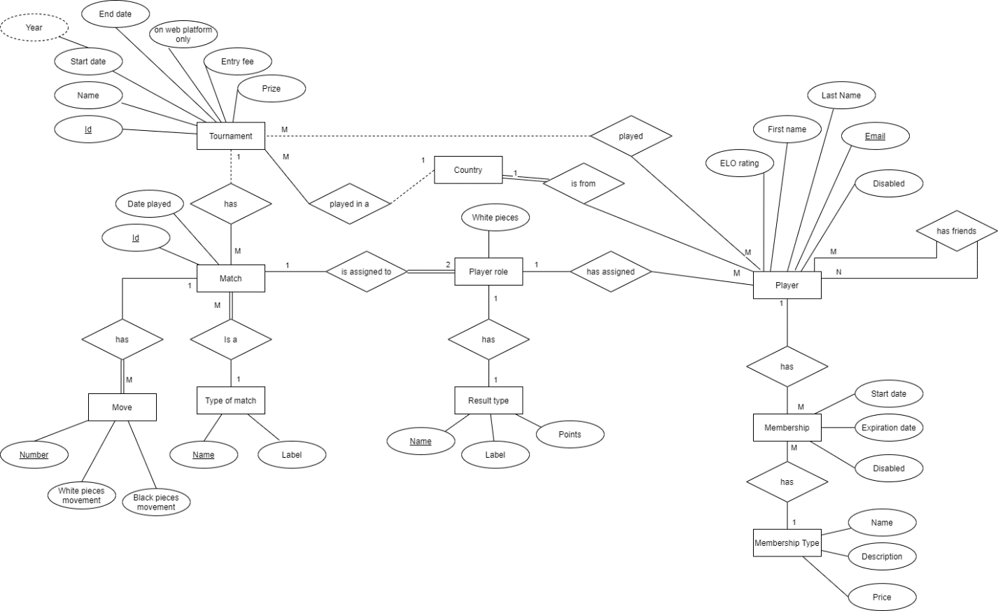

# Tables

## Player

|  |  |  |  |  |  |  |
| --- | --- | --- | --- | --- | --- | --- |
| Column name | Data type | Primary Key | Foreign Key | Not null | Reference to | Constraint |
| id | int | X |  | X |  |  |
| firstName | varchar(50) |  |  | X |  |  |
| lastName | varchar(50) |  |  | X |  |  |
| email | varchar(50) |  |  |  |  | Unique |
| elo | int |  |  | X |  |  |
| countryId | int |  | X | X | Country (id) |  |
| disabled | tinyint(1) |  |  |  |  |  |

## Membership

|  |  |  |  |  |  |  |
| --- | --- | --- | --- | --- | --- | --- |
| Column name | Data type | Primary Key | Foreign Key | Not null | Reference to | Constraint |
| id | int | X |  | X |  |  |
| playerId | int |  | X | X | Player(id) |  |
| membershipTypeId | int |  | X | X | MembershipType(id) |  |
| startDate | date |  |  | X |  |  |
| expirationDate | date |  |  | X |  |  |
| disabled | tinyint(1) |  |  |  |  |  |

## MembershipType

|  |  |  |  |  |  |  |
| --- | --- | --- | --- | --- | --- | --- |
| Column name | Data type | Primary Key | Foreign Key | Not null | Reference to | Constraint |
| id | int | X |  | X |  |  |
| name | varchar(50) |  |  | X |  |  |
| description | varchar(250) |  |  | X |  |  |
| price | decimal(10,2) |  |  | X |  |  |

## PlayerRole

|  |  |  |  |  |  |  |
| --- | --- | --- | --- | --- | --- | --- |
| Column name | Data type | Primary Key | Foreign Key | Not null | Reference to | Constraint |
| playerId | int | X | X | X | Player(id) |  |
| matchGameId | int | X | X | X | MatchGame(Id) |  |
| white | tinyint(1) | X |  | X |  |  |
| resultTypeId | int |  | X | X | ResultType(Id) |  |

## MatchGame

|  |  |  |  |  |  |  |
| --- | --- | --- | --- | --- | --- | --- |
| Column name | Data type | Primary Key | Foreign Key | Not null | Reference to | Constraint |
| id | int | X |  | X |  |  |
| typeOfMatchId | int |  | X | X | TypeOfMatch(Id) |  |
| datePlayed | date |  |  | X |  |  |

## TypeOfMatch

|  |  |  |  |  |  |  |
| --- | --- | --- | --- | --- | --- | --- |
| Column name | Data type | Primary Key | Foreign Key | Not null | Reference to | Constraint |
| id | int | X |  | X |  |  |
| name | varchar(50) |  |  | X |  |  |
| label | varchar(50) |  |  |  |  |  |

## ResultType

|  |  |  |  |  |  |  |
| --- | --- | --- | --- | --- | --- | --- |
| Column name | Data type | Primary Key | Foreign Key | Not null | Reference to | Constraint |
| id | int | X |  | X |  |  |
| name | varchar(50) |  |  |  |  |  |
| label | varchar(50) |  |  |  |  |  |
| points | float |  |  | X |  |  |

## Tournament

|  |  |  |  |  |  |  |
| --- | --- | --- | --- | --- | --- | --- |
| Column name | Data type | Primary Key | Foreign Key | Not null | Reference to | Constraint |
| id | int | X |  | X |  |  |
| name | varchar(100) |  |  | X |  |  |
| year | year |  |  | X |  |  |
| startDate | date |  |  |  |  |  |
| endDate | date |  |  |  |  |  |
| countryId | int |  | X |  | Country(Id) |  |
| onWebPlatform | tinyint(1) |  |  |  |  |  |
| entryFee | decimal(10,2) |  |  |  |  |  |
| prize | decimal(10,2) |  |  |  |  |  |

## TournamentMatch

|  |  |  |  |  |  |  |
| --- | --- | --- | --- | --- | --- | --- |
| Column name | Data type | Primary Key | Foreign Key | Not null | Reference to | Constraint |
| tournamentId | int | X | X | X | Tournament(id) |  |
| matchId | int | X | X | X | MatchGame(Id) |  |

## TournamentPlayer

|  |  |  |  |  |  |  |
| --- | --- | --- | --- | --- | --- | --- |
| Column name | Data type | Primary Key | Foreign Key | Not null | Reference to | Constraint |
| tournamentId | int | X | X | X | Tournament(id) |  |
| playerId | int | X | X | X | Player(id) |  |
| points | float |  |  | X |  |  |
| ranking | int |  |  | X |  |  |

## Move

|  |  |  |  |  |  |  |
| --- | --- | --- | --- | --- | --- | --- |
| Column name | Data type | Primary Key | Foreign Key | Not null | Reference to | Constraint |
| id | int | X |  | X |  |  |
| matchGameId | int |  | X | X | MatchGame(id) |  |
| moveOrder | int |  |  | X |  | Greater than zero |
| whiteMove | varchar(10) |  |  | X |  |  |
| blackMove | varchar(10) |  |  |  |  |  |
| whiteMoveTime | time |  |  |  |  |  |
| blackMoveTIme | time |  |  |  |  |  |

## Country

|  |  |  |  |  |  |  |
| --- | --- | --- | --- | --- | --- | --- |
| Column name | Data type | Primary Key | Foreign Key | Not null | Reference to | Constraint |
| id | int | X |  | X |  |  |
| name | varchar(50) |  |  | X |  | Unique |

# Queries

## Retrieve users with membership expired on current year.

### Expected result

* Emily Ho 2019-01-01 2020-01-01 Gold China
* Sandra Levis 2019-10-12 2020-10-12 Platinum France

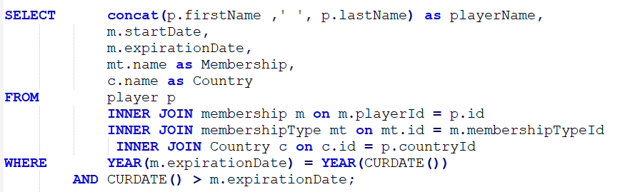

## Retrieve users with membership close to expire within a range of 1 month

### Expected result

* Charles Simpson 2020-12-22 15 Gold French Southern Territories
* Marie Hilton 2020-12-27 20 Platinum Gabon

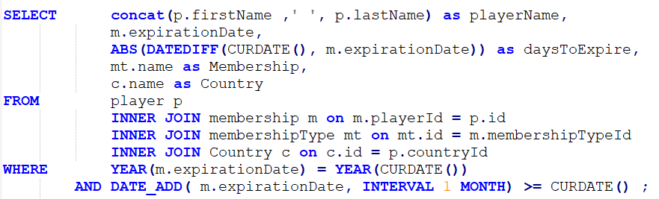

## Retrieve profits from memberships for current year

### Expected result

* 276.00

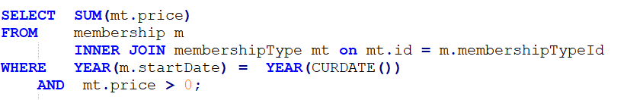

## Retrieve profits by membership for current year

### Expected result

* Gold 29.00
* Platinum 49.00
* Diamond 198.00

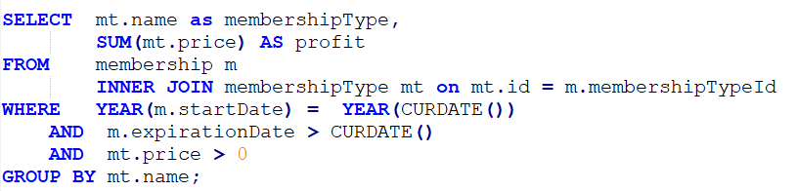

## Retrieve profit from tournaments for current year

### Expected result

* 3500.00

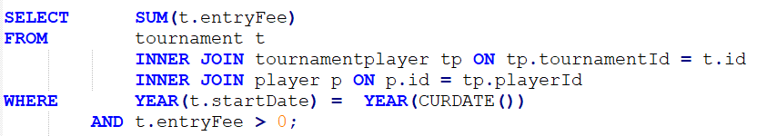

## Retrieve monthly profits from tournaments for current year

### Expected result

* 4 500.00
* 6 3000.00

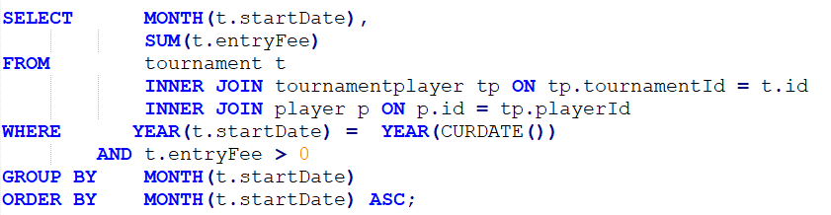

## Retrieve yearly profits for the last 2 years including current

### Expected result

* 2020 3500.00
* 2019
* 2018

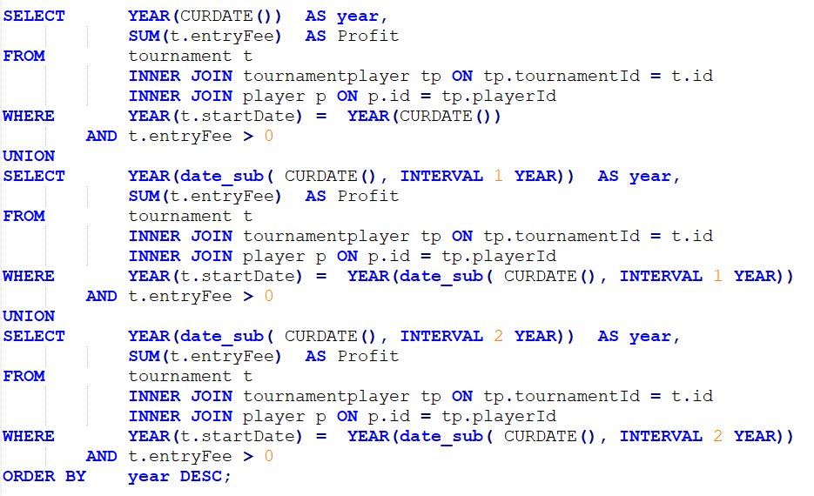

## Retrieve global ranking

### Expected result (showing only a top 3 as an example)

* Magnus Carlsen Norway 3200 1
* Hikaru Nakamura United States 3100 2
* Garry Kasparov Russian Federation 2851 3

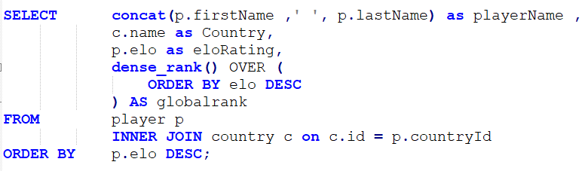

# SQL Script

The script includes:

1. Database creation.
2. Population of tables.
3. Queries.



# Chess vocabulary

Elo: Method for calculating the relative skill levels of a chess player.

PGN: Portable Game Notation (PGN) is a standard plain text format for recording chess games (both the moves and related data), which can be read by humans and is also supported by most chess software. (Wikipedia)